**Future Time Clauses**

**What is a future time clause?**

A **future time clause** is a subordinate clause that contains a [conjunction](https://english.lingolia.com/en/grammar/sentences/conjunctions) such as ***when, as soon as, before, after, until,*** etc. The special thing about these clauses is that they use a [present tense](https://english.lingolia.com/en/grammar/tenses/simple-present) to refer to an action or event in the future.

**Example**

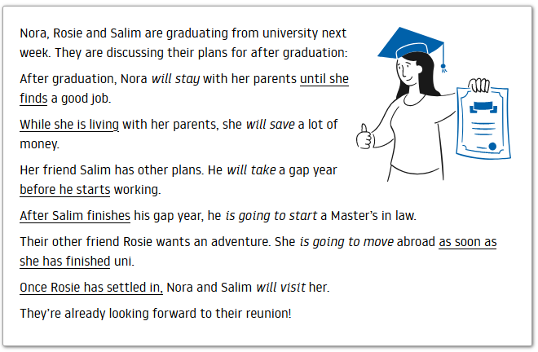

**Tenses in future time clauses**

* In sentences that contain a future time clause, the *main clause* contains a future tense (usually [*will* + infinitive),](https://english.lingolia.com/en/grammar/tenses/future-simple-will) but the time clause contains a [present tense](https://english.lingolia.com/en/grammar/tenses/simple-present).

Example: Nora *will stay* with her parents until she finds a good job.

main clause: *will;* time clause with *until: simple present*

We do not repeat the future tense.

Example: When she finds a good job, she *will move* out.

* We can use **different present tenses** in future time clauses: the [simple present](https://english.lingolia.com/en/grammar/tenses/simple-present), [present progressive](https://english.lingolia.com/en/grammar/tenses/present-progressive) or [present perfect simple](https://english.lingolia.com/en/grammar/tenses/present-perfect-simple).

Examples:

Nora *will stay* with her parents until she **finds** a good job. *(simple present)*

While she **is living** with her parents, she *will save* a lot of money. *(present progressive)*

Rosie *will move* abroad as soon as she **has finished** uni. *(present perfect)*

* Likewise, we can use **different** [**future tenses**](https://english.lingolia.com/en/grammar/tense-comparison/future-tenses) or even the [imperative](https://english.lingolia.com/en/grammar/verbs/imperative) in the main clause.

Examples:

Salim ***will take*** a gap year before he **starts** working. *(will future)*

After he **finishes** his gap year, ***he’s going to start*** a Master’s in law. *(going to + infinitive)*

While Nora **is living** at home, Rosie ***will be enjoying*** life abroad. *(future progressive)*

When I **am** settled, ***come* and visit** me! *(imperative)*

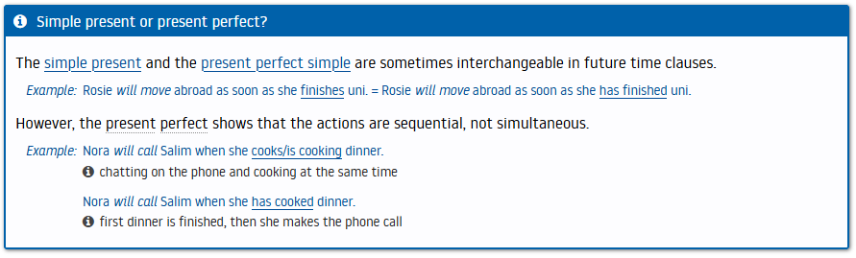

* **Punctuation in future time clauses**

Sometimes we can reverse the order of future time clauses. The meaning doesn’t change, but when the time clause comes first, it is separated from the main clause by a comma.

Example: Once Rosie has settled in, Nora and Salim will visit her. *(comma)*

Nora and Salim will visit once Rosie has settled in. *(no comma)*

* **Conjunctions in future time clauses**

**when, as soon as -** *When* means *at the time that*.

Example: They will tell Rosie when their flight lands.

* *When* signifies that we are certain that an event will happen in the future. In some languages, *when* is a false friend and is often confused with *if.* [Learn the difference between if and when](https://english.lingolia.com/en/vocabulary/confusing-words/when-if).

Example: They will tell Rosie when their flight lands. not: if their flight lands

* *As soon as* is similar to when, but it emphasises that the main clause will happen immediately following the action in the time clause.

Example: I promise that I’ll call you as soon as I have more information.

= the minute that I have more information

**before, after, once**

* *Before* means that the action in the main clause must be completed **prior** to the action in the time clause.

Example: Salim will take a gap year before he starts working. first he does a gap year, then he

starts work

* *After* is the opposite of *before;* the action in the main clause happens second.

Example: After they have graduated, the three friends will go their separate ways.

first they graduate, then they go their separate ways

* *Once* has a similar meaning to *after.*

Example: You’ll feel better once the exams are over. = after the exams are over

**while, until**

* *While* shows that two actions happen simultaneously in the future.

Example:

Nora will save money while she is living with her parents.

* *Until* means from now up to a specific time point in the future.

Example:

Rosie will live abroad until she gets bored.

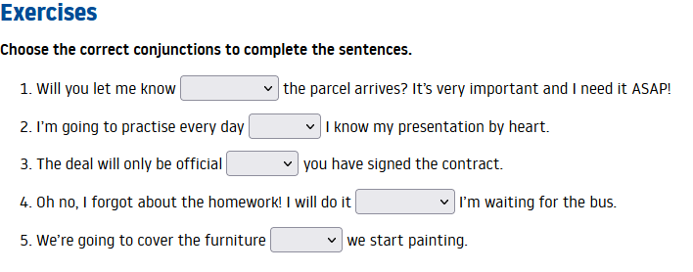

1. until, while, as soon as
2. until, when, before
3. before, once, while,
4. once, as soon as, while
5. before, after, while

Key: 1. as soon as, 2. until, 3. once, 4. while, 5. before

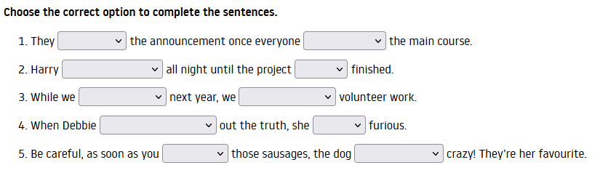

1. will make/ make ..................................... will finish/has finished
2. is going to work/works...........................will be/is
3. will travel/are travelling.......................... do/are going to do
4. is going to find out/finds.........................will be/is
5. will open/open.......................................goes/is going to go

Key: 1. will make, has finished, 2. is going to work, is, 3. are travelling, are going to do, 4. finds, will be, 5. open, is going to go